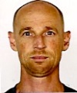 Bruce Brekhus  Camano Island,WA | 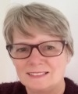  Pamela Burns  Victoria,AUS | 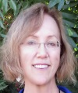  Marsha Cornwell  Sacramento,CA |   Chandra Domich  Sacramento,CA | 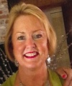  Ann Fish  Sacramento,CA
  Angela Gibson  Springfield,MO | 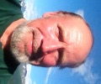Chris Kirschman  Indian,AK | 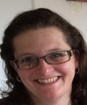  Sonya Little  Victoria,AUS | 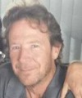  Michael Maas  Moorpark,CA |   Steph Marriner  Victoria,AUS
  Sara Mendez  Albuquerque,NM | 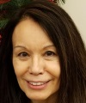Priscilla Montanelli  Anchorage,AK | 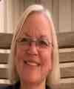 Celia Pearson  Chesire,UK | 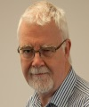 Ian Pearson  Chesire,UK | 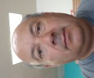  John Perea  Santa Fe,NM
  Kristen Petrarca  Vandergrift,PA | 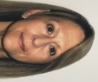  Karen Robinson  Sacramento, CA | 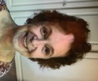  Ursula Schultz  Denver,CO | 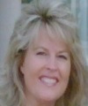Sherri Scott  Anchorage,AK | 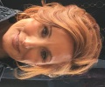  Joan Shetterly  Reston,VA
Christian Stöckli  Riehen,Switzerland | Michael Town  Clinton,MO | 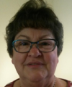Laura Vilasi  Nazareth,PA

